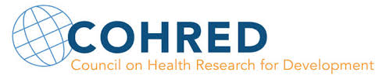

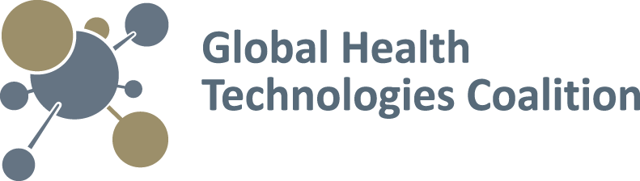

Achieving access to new innovations:

Perspectives on the challenges & opportunities of global health R&D

Summary Report

# **Introduction**

The Global Health Technologies Coalition (GHTC) is hosting a series of webinars to inform and engage global health stakeholders, including both product developers and advocates. Each webinar focuses on a topic critical to global health research and development (R&D) and is designed to provide balanced information that draws from diverse perspectives.

On May 18, 2015, GHTC and the Council on Health Research for Development (COHRED) held a webinar in Geneva, Switzerland, to explore approaches to incentivizing global health R&D and achieving access to new global health innovations. The webinar was facilitated by Claire Wingfield, Product Development Policy Officer at PATH, and panelists included:

* John-Arne Røttingen, Director of Division of Infectious Disease Control, Norwegian Institute of Public Health (former cochair of the World Health Organization [WHO] Consultative Expert Working Group on Research and Development [CEWG])
* George Jagoe, Executive Vice President of Access & Product Management, Medicines for Malaria Venture (MMV)
* Dr. Denis Broun, Global Director for Access & Public Affairs, Cipla (former Executive Director at UNITAID)
* Dr. Manica Balasegaram, Executive Director of the Access Campaign, Médicines Sans Frontières (MSF)

This document provides summaries of each panelist’s opening presentation, as well as syntheses of panelists’ responses to audience questions. Additional questions submitted by audience members and audience members’ feedback on the webinar are provided in Appendices A and B.

# **Panel presentations**

## Improving access to global health R&D through the CEWG

## *John-Arne Røttingen, Director of Division of Infectious Disease Control, Norwegian Institute of Public Health*

### Innovation and access business models: Today vs. tomorrow

The current business model of innovation and access to a new or existing health technology is that a public health need (i.e. market) directs and incentivizes R&D in the private sector—because the market has an ability to pay for future products, there is a strong incentive for private-sector investors to invest in the long-term development of new health technologies. Large health markets signal a stronger incentive for investing in R&D, while smaller health markets provide less incentive for and, consequently, less investment in R&D. As a result, all public health needs will not be met.

Under the current business model, when there is an imbalance between a large public health need and the purchasing power in the markets with that need, there is little incentive for private-sector investment in innovation and R&D for new treatments and tools to meet that need. There are two approaches for correcting this imbalance and boosting investment in R&D (see Figure 1):

1. **Delinkage/Push mechanisms:** Invest public funds directly into R&D or subsidize private costs to separate costs of R&D from the costs of technology production and commercial sale price (e.g., grants and product development partnership [PDP] financing).
2. **Market shaping/Pull mechanisms:** Expand market for products to address unmet needs in order to increase incentives for private-sector innovation in these areas (e.g., advance market commitments).

Figure 1. Delinkage/Push Mechanisms vs. Market Shaping/Pull Mechanisms

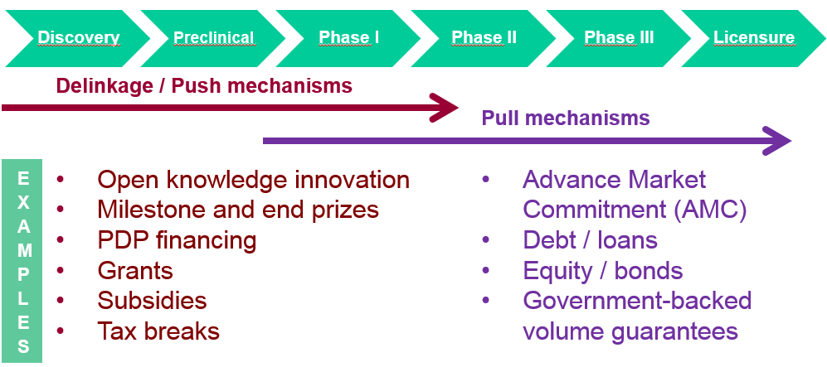

### Role of CEWG

The WHO CEWG was a group of experts appointed to pull together existing knowledge and provide recommendations on how the global R&D system can achieve both innovation and access to new medical technologies for those in need. It was formed following an extended process that began with the Commission on Intellectual Property Rights, Innovation, and Public Health in 2003; continued into approximately three years of negotiations at the WHO through the Institute for Quality and Efficiency in Health Care; and concluded with the [Global Strategy and Plan of Action for Innovation and Intellectual Property](http://www.who.int/phi/publications/Global_Strategy_Plan_Action.pdf) formally in 2009.

The global strategy requested that an expert working group be appointed by WHO to review and report out on existing ideas and proposals for coordinating and financing R&D, but for various reasons, WHO did not endorse their report. Instead, they requested a new expert group: the CEWG.

In 2012, the CEWG developed a new report and sent it to WHO. Following the report’s recommendations, WHO decided in 2013 to establish a global health R&D observatory and to start small-scale demonstration projects that could explore R&D coordination and financing mechanisms. WHO further discussed at the 2014 World Health Assembly (WHA) how to define, solicit, and fund the demonstration projects, and in 2015, the secretariat made a formal recommendation to its governing bodies to 1) establish the global observatory and to 2) establish coordination mechanisms and a pooled fund at the WHO Special Program for Research and Training in Tropical Diseases (TDR).

As a result of this effort, 23 demonstration projects were submitted and five winners were selected based on criteria developed by the WHA that were partially shaped by the recommendations of the CEWG. The current challenge is financing the projects, which will require US$60 million. While this is a small amount compared with the $3 billion of increased investment that the CEWG called for in health R&D, it will require financial contribution from all countries scaled to their economic capacity.

How access fits into the PDP approach

*George Jagoe, Medicines for Malaria Venture*

### Role of PDPs in ensuring access

Issues of drug availability, affordability, and acceptability are of central importance when developing new medicines. These access-related issues must be considered early in the drug development cycle to maximize the impact of new medicines for patients.

MMV is a product development partnership (PDP) focused on the development of malaria medicines, including both treatments and chemoprevention agents. Within MMV, access is considered beginning from the development phase of a new product all the way through distribution and delivery (see Figure 2).

Figure 2. MMV Product Development Process

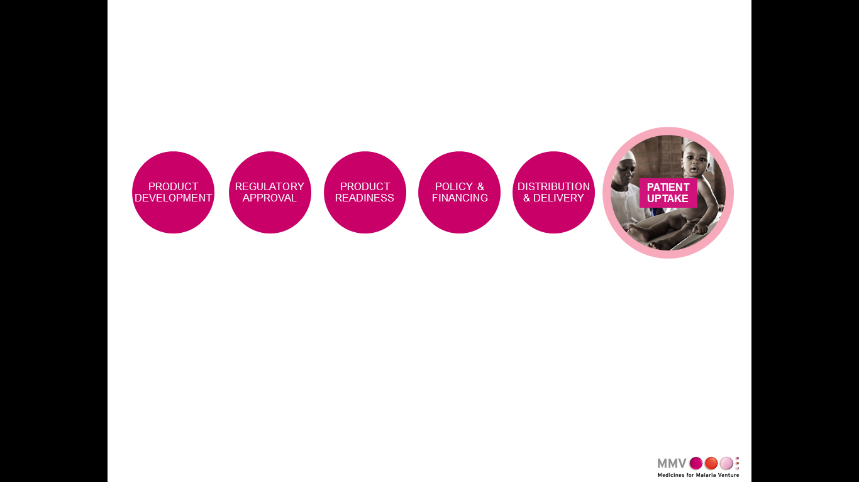

In the development phase, it is critical to define a target product profile (TPP) that ensures the technology will meet end users’ needs (including affordability and acceptability) and then remain accountable to that profile throughout the development process. Once regulatory approval for the drug is anticipated, product readiness, policy and financing, and product distribution and delivery must all be considered. By following these steps, PDPs and partner organizations can help to ensure that medications reach their target patients.

### The case of injectable artesunate

Injectable artesunate provides a case study on the challenges of achieving access and how PDPs and partner organizations can work together to overcome them. Despite its potential to save 200,000 of the almost 600,000 lives lost to malaria annually, in the early 2000s, injectable artesunate initially lacked adequate efficacy evidence for WHO to recommend it as the preferred treatment for severe malaria in African patients.

Starting in 2010, however, positive results from drug trials among African children were coupled with the actions of a number of organizations to bring injectable artesunate one step closer to widespread distribution. These actions included WHO Prequalification’s timely evaluation and approval of the injectable; WHO Global Malaria Program’s modification of their malaria standard treatment guidelines to recommend widespread use of injectable artesunate; and MSF’s development of a compelling advocacy paper for injectable artesunate that outlined the evidence of its lifesaving impact, costs, and long-term cost efficacy.

In addition, MMV began engaging with implementing partners and national malaria control programs to advocate for policy change and adoption of the drug. It quickly became obvious through these discussions that the cost of injectable artesunate—seven times more expensive than widely used treatment quinine—was an immediate barrier to the drug’s adoption in many countries. To address this concern, MMV and its partners submitted a proposal to UNITAID proposing three focus areas:

1. Finance introduction of injectable artesunate in six countries with a high malaria burden that were willing to adopt it—accompanied by rapid policy change and supportive training interventions to ensure correct use of the medicine.
2. Help MMV and its partners diversify the injectable artesunate marketplace by incentivizing additional prequalified suppliers (there is currently only one prequalified manufacturer).
3. Use the work and lessons learned from the initial six countries to catalyze similar efforts in additional countries.

Although MMV and its partners are only halfway through this grant process, several countries beyond the initial six are already adopting injectable artesunate—over 20 countries to date are buying the medication. This success would not have been possible without WHO, MSF, MMV and other partners working through the entire process from product development through patient uptake.

Balancing profit margins against the need to create products that are acceptable, affordable, and accessible

*Dr. Denis Broun, Cipla*

### Pharmaceutical vs. generic approach to R&D

Within drug industry R&D, there are two types of companies: research-based pharmaceutical companies and generic companies. Traditionally, these two types of companies do not work in the same ways.

**Research-based pharmaceutical companies** discover new molecules that could lead to a new product, or purchase promising compounds from research organizations or universities. They develop the new molecules into a new drug, then establish themselves in a patent network to create a monopoly on the drug’s production. These companies charge very high prices for their drugs to recoup R&D costs and only develop drugs for the countries that can afford their high prices, which results in very little research into treatments for diseases endemic to lower-income countries. [A tangential result is that the manufacturing and regulatory fields in lower-income countries are under-developed.]

**Generic companies**, on the other hand, exist in a competitive environment with no intellectual property protections. They work to improve upon the chemical composition of drugs and find cheaper raw materials so that they can produce and sell their drugs at a lower price than their competitors. In some cases, generic companies have begun to engage in R&D to develop derivatives of existing products.

When it comes to achieving access to new technologies, there is a tendency to focus only on reducing price as a way to make drugs more accessible. While cost issues are important to improving access, they must be considered alongside a host of additional factors.

### Considerations for improving access

**Quality of the raw materials:** Simply reducing the cost of drug production can risk drug quality. For example, the cheapest active pharmaceutical agent (API) available for Entecavir [an oral antiviral drug used in the treatment of hepatitis B] is $54, but the cheapest quality-assured API available for Entecavir is $400. Reducing the quality of the API could drastically reduce the price of the drug, but it would come at too high a risk to the patient.

**Financing for purchasing in place:** Even drastically decreasing the price of a drug may still not make it affordable to patients, unless prices are made to fit the purchasing abilities of the target population. Without financing or government programs to subsidize the purchase of these drugs, they will not be accessible to many of the patients who need them. For example, Gilead’s initial treatment for Hepatitis C originally cost $84,000. Generic companies brought this price down to $450, but this is still not affordable to patients in low-income countries. Currently, Egypt is the only country that helps patients pay for the treatment.

**Regulatory barriers:** It typically takes several years to get products registered in countries where it will be used, and 2–3 years to prequalify a drug through WHO once it has been developed, often because registration authorities are not sufficiently organized or do not have sufficient capacity. This lag time drastically delays drug distribution and poses a major obstacle to improving drug access.

**Weak health systems:** Disseminating a drug to patients requires a robust and reliable distribution system, which frequently does not exist in low-income countries. Without establishing or improving these systems, many people will never have access to a new medication and many patients with chronic diseases will not be able to adhere their treatment regimens, regardless of cost.

### Product price negotiations and the Global Fund

While other aspects of drug development and delivery must also be improved, price will continue to play a major role. One approach that has been effective at reducing prices is that used by the Global Fund. This organization reviews a company’s cost of goods and cost of manufacturing, among other factors, and then works with the company to negotiate a reduced price while still ensuring the company can earn a profit margin. The Global Fund then places a long-term order of two years, so that companies know they will not have idle capacity and are guaranteed to have product uptake.

Key principles and proposals outlined in [MSF article in PLOS Medicine](http://journals.plos.org/plosmedicine/article?id=10.1371/journal.pmed.1001831)

*Dr. Manica Balasegaram, Médicines Sans Frontières*

### Broader issues impacting R&D and access

There are several issues impacting R&D and access that need to be considered, especially when thinking about the future. These include market failure (e.g., meeting the need for R&D in resource-limited settings, ensuring outcome is affordable, and promoting a collaborative rather than competitive environment); R&D process issues (e.g., conducting more contextualized risk-benefit analyses, doing ethical and feasible trials, shifting more of the research process to local researchers, and better handling biological samples); regulatory issues; and post-trial access issues. Developing TPPs can be useful in providing guidance on how to navigate some of these issues by better defining R&D needs to ensure a product is adapted to needs on the ground. It is important that TPPs be realistic and not just aspirational.

### Specific cost barriers to innovation and access

While the price of a product is not the only factor in play, it can be a barrier to innovation and access; developing new financing mechanisms to fund product purchase or improving distribution won’t matter if the price of a drug is completely unreasonable (e.g., $80,000 for Gilead Hepatitis C treatment). Additional issues include the lack of transparency in R&D, which makes it difficult to assess what the R&D costs were for the product and who paid for (i.e., whether it received substantial public funding). In the current model, public funding accounts for around 30-40% of R&D funding, which in some cases can mean the public is paying both on the development side and purchase side. Another barrier to access is that research-based (non-generic) companies often base their prices on what they think the market can pay, rather than the cost of production, which ignores populations that don’t have a strong markets and underestimates spending pressures and financing strains faced by ministries of health.

WHO can help address some of these barriers by continuing to coordinate R&D, but it will be important to maintain the Trade-Related Aspects of Intellectual Property Rights (TRIPS) Agreement flexibilities. As the policy landscape changes with new trade agreements, it is unclear whether the guarantees of TRIPS flexibilities will survive in the future.

### Potential solutions in the post-CEWG era

The MSF article focused on the fact that the global health community is still not really connecting the dots when it comes to gaining political traction for and making progress in addressing access and innovation issues. Rather, the issues surrounding market failure and innovation continue to occur, repeatedly resulting in severe costs to human life (e.g., the recent Ebola outbreak).

Potential actions that could aid the global health community in moving needs-driven R&D forward include the following:

* **Mapping out current R&D financial flows, delineating R&D priorities, and identifying major R&D gaps** by leveraging the work of the WHO Global Health R&D Observatory.
* **Increasing coordination between funders**, using information and guiding priorities from the Global Observatory and platforms for member state discussions provided by organizations like WHO and TDR.
* **Establishing research platforms for a variety of diseases**, not just in emerging and infectious disease outbreaks (going forward, it will be important not to silo the on-the-ground capacities that currently exist in HIV, tuberculosis (TB), or neglected diseases).
* **Increasing endemic country involvement**, including increased funding commitments from endemic countries, which should have very quick payoffs and provide ancillary benefits to countries.
* **Establishing a complementary, sustainably-financed, global R&D fund and mechanism** to cover the R&D components of three priority areas: antimicrobial resistance (AMR), emerging infections, and neglected diseases (see Figure 3). A pooled fund will only be able to address the most acute disease priorities, however, so work must be done in tandem with other funders, which can be facilitated by the Global Observatory’s monitoring and coordination activities.

Figure 3. Example of structure of proposed R&D ecosystem

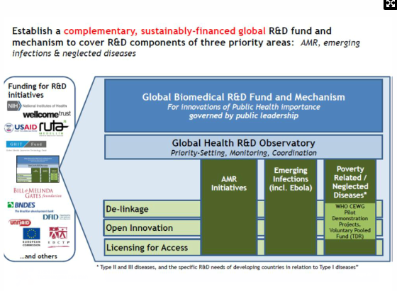

### Example: Open collaborative model for TB

Currently, two new chemical entities are provisionally registered for TB but they have never been tested before and will require additional research to understand how to use them in tandem with one another. In addition, both drugs are moving toward donation models and have experienced access issues at the country level as well as regulatory issues.

As a result, the global health community needs to identify a model—drawing on push, pull, and pooled funding mechanisms—that can optimize the way TB innovation is currently working, even with limited resources (see Figure 4).

**Push mechanisms** fund product development inputs (e.g., research grants). To improve current push funding, major R&D gaps need to be identified and including those in translational space.

**Pull mechanisms** fund product development outputs (e.g., subsidizing product costs). Current pull mechanisms are constrained by market failures, so alternative pull incentives for health R&D need to be identified, such as milestone payments, prizes, or marketing commitments.

**Pooling mechanisms**, such as patent pools, can be improved by taking more of an upstream step and finding ways to bring innovators and generic manufacturers together at an earlier stage of the R&D process to share technology and ultimately optimize the development of combination regimens.[1]

Figure 4. Open collaborative model for TB



# **Questions and Discussion**

**Q: Technologies that are not aimed at neglected tropical diseases (NTDs) are often missing from global health R&D conversations. In a post-CEWG era of thinking, where does R&D for issues like family planning—which is an acute, unmet need, and has a commercial market—fit into the broader framework?**

**A:** Within the WHO process, R&D was really about addressing market needs, so it was never limited to NTDs. Instead, WHO’s process looks at all markets that have insufficient purchasing power, including family planning devices, technologies, and medicines for middle- and low-income countries. Whether there is an existing commercial market or not, when we are talking about innovation and access, many challenges remain the same, including strength of health systems, capacity of health systems to pay, and ability to ensure products reach those patients in need. Additionally, there is a real need for innovation within healthcare systems and in improving access to new drugs and technologies. These issues are independent of getting approval for new types of health interventions and there needs to be a high-level policy process for revisiting those issues and achieving change.

**Q: What role can implementing partners, and international NGOs more broadly, play in mitigating risks and contributing to lower product cost and greater product access? In essence, what is the role they can play in facilitating access to new global health technologies?**

**A:** Working with country implementing partners is critical. Country implementing partners—for example, MSF, Clinton Foundation Health Access Initiative, Malaria Consortium, Population Services International, and Save the Children—have a trusted relationship with ministries of health, are sensitive and catalytic around financing and training needs, and can work well with in-country stakeholders. These partners can be very helpful in informing product development and help catalyze the introduction of new interventions.

**Q: How do TPPs evolve in response to new clinical data and landscape shifts and changes, and how do we ensure that commitments to access are foremost and driving product development? From a more technical standpoint, how do you negotiate access commitments at the beginning of the R&D process and then throughout the R&D process, when it can be hard to know what the access needs are before having a lot of clinical data?**

**A:** Any number of snags can occur over the course of a product’s development, and you must respond to them as best you can. For example, Cipla has been working with the Drugs for Neglected Diseases *initiative* to develop pediatric drugs in powder form that can be put on children’s food. However, it was discovered to be much more technically complicated than expected, so a new approach had to be developed that could meet the same original purpose; then, the new product was found to have a terrible taste, and Cipla had to find ways to mask it.

At MMV we talk about target candidate profiles (TCPs) as well as TPPs, because we often combine multiple drugs to create a final product. Ultimately, TPPs and TCPs are the anchoring vision for product development and should be adhered to rigorously. It is better to step away from candidates that don’t match the TCP, rather than bend the TCP to a candidate you think could work.

With regards to maintaining a commitment to access as TPPs evolve; you must have clear founding principles with your partner. There need to be contractual commitments around pricing that are linked to the cost structure of the finished product. You must also have clear delivery commitments. While you can’t make delivery commitments in absolute numbers, you can commit to country registration targets, and you can commit to finding new partners to assist you if you are unable to meet those registration targets.

**Q: There are many thousands of actors from the public, private, nonprofit, and philanthropic sectors involved in global health R&D. What do you envision when you talk about coordination?   
What coordination mechanisms would you pay attention to?**

**A:** Getting funding is a very competitive field. It requires a lot of front-end work from companies in terms of advocacy and visibility that does not typically deliver more than the potential of getting funding. The cost of fundraising needs to be reduced to shift those resources into real product development. To do that, funders who are already committed need to coordinate their efforts, aligning their mechanisms for funding as well as the ways they grant funds to PDPs and other partnerships. In addition, while there are thousands of funders, only a small subset of them account for the majority of funding. Focusing on coordination among those funders would be very useful.

The global health community should also look at the coordination efforts that have worked in the past. These include the ways that PDPs have helped R&D evolve, as well as how to bring people together, prioritize ways to do R&D, and pool and channel resources to a range of actors.

A norm-setting agency like WHO, which has links to different technical departments as well as member states, will also be key. While there will be reluctance to using these mechanisms which are seen as slow, R&D is a long-term process which requires a long-term vision. Unfortunately, the biggest problem facing the global health community now is that there is no clear long-term vision within global health, including within the innovation sphere.

**Q: How would you incentivize that long-term vision?**

**A:** Creating the vision requires political commitment. A long-term vision is not going to be provided by stopgap measures or foundations. At the end of the day, governments are the ones responsible for the health of their people.

PDPs themselves must be very humble about defining priorities, even within their own disease space. In terms of compound quality, Independent Expert Scientific Advisory Committees hold PDPs accountable to make sure they remain focused on viable candidates. In terms of monitoring changes in global priorities, MMV closely follows the guidance of WHO, particularly the Global Malaria Program (GMP). MMV also tries to remain appraised of ongoing needs and advancements and interact with other organizations. For example, the ability to use two existing malaria drugs as seasonal malaria chemoprevention was discovered by researchers in the field. As the results of this research were disseminated at international conferences and WHO GMP began to prioritize this as a potential lifesaving intervention, MMV followed WHO’s lead to determine how best to support the scale-up of global manufacturing for this medicine.

**Q: Denis, do you have last thoughts you want to share with the group as we get close to the end?**

**A:** I realize I did not answer your original question: how do stockholders respond to creating products that are accessible and affordable? At Cipla, stockholders know our business model. They know it is based on access—that 25% of our business is in Africa, 1/3 of our exports are products for the poor, and less than 20% of our turnover is in Europe, Japan, America, and other rich countries. They know that our growth is slower than other companies and that we won’t sell our shares to a multinational. Yet our stockholders are still on board with our work, and the prices of our stocks are very high. This does not mean that our stockholders are saints, but it does mean that providing access for the poor is a business model that can be successful.

**Q: John-Arne, since you kicked us off, I’d like to give you the final word from the panelists.**

**A:** I would definitely say that we are in a post-CEWG world. I hope that by the end of the summer we are also in a post-West-Africa-Ebola-outbreak world. I hope, also, that the United Nations high-level panel is quick to take up current R&D challenges, to see Ebola as a disaster that could have been greatly diminished if we had taken candidate medicines and vaccines, which were already advanced, through early stage clinical development.

We need long-term vision, and that is the role of politicians. Some of the panel members are heads of states and politicians who hopefully understand that we need to deliver on what has been on the drawing board for many years now.

# **How to Engage Further**

* Twitter: [@GHTCoalition](https://twitter.com/ghtcoalition)
* Facebook: [www.facebook.com/GHTCBreakthroughs](http://www.facebook.com/GHTCBreakthroughs)
* Newsletter: e-mail [info@ghtcoalition.org](mailto:info@ghtcoalition.org) to join
* Blog: <http://blog.ghtcoalition.org/>
* Website: [www.GHTCoalition.org](http://www.GHTCoalition.org)

# **Appendix A: Additional questions submitted**

* It's been more than two years since the CEWG concluded its report and recommendations. Why is it taking so long to implement, and what can we collectively do to accelerate that implementation?
* What are some examples of access/product dissemination and implementation mechanisms that have worked in markets characterized by a lack of purchasing power (e.g., diagnostics for poverty-related diseases)?
* Pharma industries contribute to the economy of countries like India. Is this a barrier or driver to innovation and access?
* Lack of transparency of R&D costs is a serious problem. Can we incentivize more transparency?
* The concept of milestone prizes is intriguing. How large would they need to be and how do you know how big they need to be?
* From the start, startups are incentivized to offer customers niche solutions that offer them the most value. Large organizations are not incentivized as much to work on minimal overlap, niche solutions (e.g., Glaxo claims that most pharma companies work on only a small subset of all tyrosine kinases, which hampers progress). According to you, what are the barriers and solutions to large system innovation few people know of?
* R&D for developed product not under insurance coverage plans: a point of market sales for adoption in insurance coverage?
* R&D requires investment, but many of the products we need don’t offer a large return on investment. Which incentives do and don’t work for motivating companies to invest in R&D for low-profit products?
* What role could the international nongovernmental organizations that raise funds (from the public) for service delivery play in the R&D of new tools and in ensuring that those tools are accessible/affordable to those who need them most?
* Since May 18 is HIV Vaccine Awareness Day, do you have any thoughts on best practices to make the HIV vaccine available quickly after being approved? (There are two vaccine candidates slated for phase III testing around 2017.)
* What is the role of "advanced developing countries" in R&D to address poverty-related diseases?
* How can our patients with rare diseases get new medicines if the medicines are very expensive and the drug companies didn’t register the drug in Egypt because they cannot guarantee that they will sell enough of the medicine to offset the cost of registration?
* Unlike the pharmaceutical market, the market for diagnostics is highly unregulated. What are some ways to stimulate the uptake of high-quality diagnostic tests, even when at a higher cost?
* What are the global health R&D needs for chronic diseases and how can related challenges be best addressed (e.g., partnerships, industry commitments, etc.)?
* What are your thoughts on WHO's decision to include sofubusivir in its EML? How will this affect other priorities of countries?
* How does vector control play into eradicating malaria?

# **Appendix B: Assessment of webinar series**

This report assesses the overall success and value of the webinar, across a range of metrics.

### Webinar participation

A total of 150 people registered for the webinar and 94 people viewed it online. . In addition, 12 people attended the live panel event in Geneva, Switzerland. This brings total viewership to 106 people. This is about a 17 percent decrease in viewership compared with GHTC’s previous webinar on the post-2015 agenda. Viewers from 21 different countries joined webinar.

Of the 94 people who viewed the webinar online, 77 people watched at least 30 minutes of the webinar, 63 watched at least an hour, and 51 watched the entire webinar (or up to the last 5 minutes of the webinar):

* 47 people viewed the webinar live.
* 33 people viewed the webinar on demand.
* 14 people viewed the webinar both live and on demand.

### Audience member feedback

Due to an error with the online survey, feedback from online viewers was not solicited immediately after the conclusion of the webinar, and responses were therefore limited.

Of the online viewers who responded to a follow-up survey:

* **All respondents** indicated that they had some knowledge of the subject matter before joining the webinar.
* **All respondents** indicated that the **webinar was somewhat helpful or very helpful in increasing their understanding of the subject**.
* **All respondents** indicated that they **would be somewhat likely or very likely to recommend the webinar** to a colleague/friend.

When asked why they provided this response, the respondents indicated that the webinar provided important information on current discussions and issues that could be accessed without travel and that the panelists were relevant and knowledge. One of the respondents indicated that it would depend on their line of work given the webinar would be most helpful with some knowledge of issues beforehand, and another said the panelist presentations were not well organized, and they did not stay on topic.

When asked what they would change to improve future webinars, respondents recommended:

* The possibility to ask questions from the outside participants.
* Providing recommended reading or background documents on the subject matter, noting that this subject was complicated and panelists addressed it at level of detail that would be hard to follow for someone not familiar.
* Having slides present for each panelist, and ensuring that they have discussed what will be present in advance to avoid duplication.

After the live event, 8 attendants offered their overall feedback in a brief survey:

* 5 of the 8 respondents indicated that they had extensive knowledge of the subject matter before joining the event. Three respondents indicated that they had some knowledge.
* 7 of the 8 respondents indicated that the event was helpful or very helpful in increasing their understanding of the subject. The remaining respondent indicated that the event was somewhat helpful.
* 7 of the 8 respondents indicated that they would be somewhat likely or very likely to recommend the on-demand video of the event to a colleague/friend. The remaining respondent indicated that they were somewhat unlikely to recommend.
  + When asked why they provided this response, the respondents indicated that the panelists should provide executive summaries given the limited time available. Another respondent indicated that the event was good for those interested in the issue area, but not for experts.

When asked about the event’s length, respondents indicated the following:

* 6 respondents indicated that it was just the right length.
* 1 indicated that it was a little long.
* 1 indicated that it was a little short.

When asked what they would change to improve future events/webinars, respondents recommended:

* Have everyone present three concrete solutions to the problem, then have panelists choose the three they all agree on.
* Include a brand name pharmacy originator on the panel.
* Have panelists provide a bold statement in response to the main question, then let them expand on that response.

### Audience proposed topics for future webinars

* Emerging donors and the changing role of WHO.
* The position of the G7 on health and the SDGs.
* How big do prizes need to be, and who will finance them?
* Drugs and vaccines in the pipeline.
* The role of civil society organizations in R&D.
* New developments in implementation of best interventions.
* Technology transfer mechanisms.
* Regulatory issues.

1. Pooling mechanisms are distinct from pooled funding mechanisms. Pooling mechanisms refer to pooling of intellectual property to promote open collaborative research and licensing. Pooled funding mechanisms are a type of push mechanism which brings together financing from multiple donors to fund R&D. For more information about push, pull, and pooling mechanisms, visit [MSF’s 3P Project.](http://www.msfaccess.org/3Ps-project)